**Team Event**

**(Niharika, Rhea, Sweta )**

.1)Meet the exciting version of charades: In first round there will be a geometric dumb charades in which a geometric diagram will be given to one teammate and he will narrate it to his teammate by mouth and other one has to draw it.

2) Boat Huddle :Get ready for the exciting boat racing competition. Teams will need to complete small tasks and overcome certain obstacles in the shortest duration to win this competition. Obstacles and tasks would consists of coding, general knowlege and aptitude based questions

3) Third one will be reverse coding in which output will given to team and they will prepare a source code for it.

First round can have questions like

a) which was tge first PC virus??

Name the organization by the logos



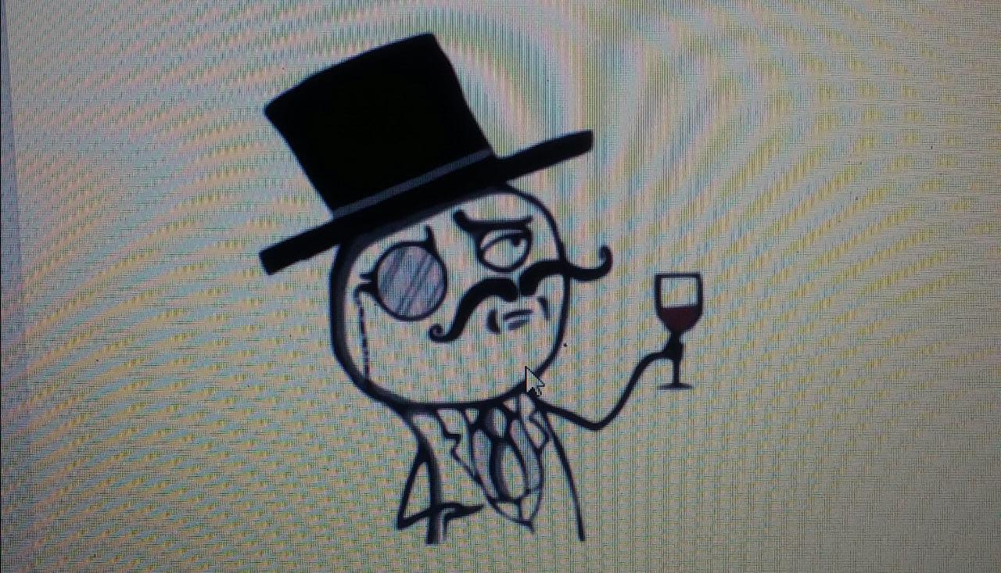

For first round geometric figures can be given to narrate.

